***Rates of Growth in Universal Health Coverage Service Coverage Index (UHC SCI) increase in PEPFAR supported countries***

In a review of the population-weighted average UHC SCI within low-income countries within Sub-Saharan Africa, the average UHC SCI increased between 2000 to 2019. When disaggregated by PEPFAR support status, countries supported by PEPFAR saw higher rates of increase in UHC SCI when compared to countries not supported by PEPFAR. Our findings are supported by the WHO’s “Tracking Universal Health Coverage in the WHO African Region, 2022” which reported growth in universal health service coverage index across all World Bank income groups with all groups reporting increases between 20-25 points overall1.

RATE OF GROWTH IN **POPULATION–WEIGHTED HEALTH SERVICE COVERAGE INDEX** IN PEPFAR SUPPORTED LOWER INCOME COUNTRIES IN SUB-SAHARAN AFRICANOUTPACED THAT OF  NON-PEPFAR SUPPORTED COUNTRIES

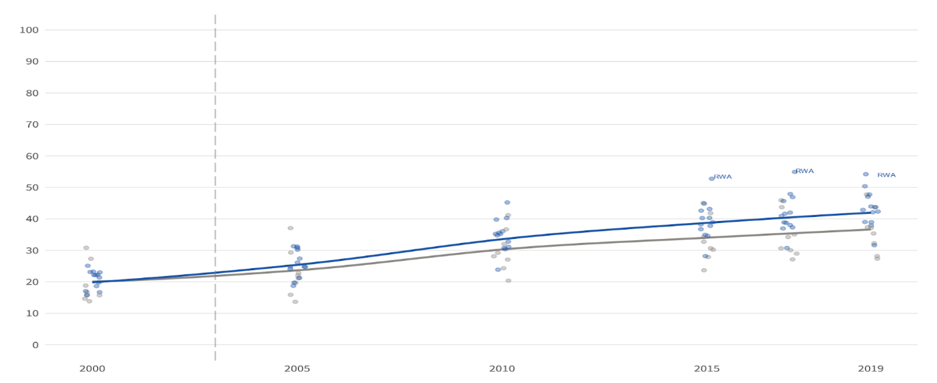

The population-weighted average universal health service coverage index within low-income countries in Sub-Saharan Africa was 20 in 2000. By 2019, this had risen to 42 within countries supported by PEPFAR (Togo, South Sudan, Sierra Leone, Rwanda, Mozambique, Mali, Malawi, Liberia, Ethiopia, Democratic Republic of the Congo, Burundi, Burkina Faso, Uganda) and rose to 37 in countries which are not supported by PEPFAR (Central African Republic, Chad, Gambia, Guinea, Madagascar, Niger, Somalia, Sudan).

A similar pattern was observed within the UHC SCI infectious disease subindex which

RATE OF GROWTH IN **POPULATION WEIGHTED HEALTH SERVICE COVERAGE INDEX (INFECTIOUS DISEASE SUB-INDEX)** IN PEPFAR SUPPORTED LOWER INCOME COUNTRIES IN SUB-SAHARAN AFRICAN OUTPACES THAT OF NON-PEPFAR SUPPORTED COUNTRIES

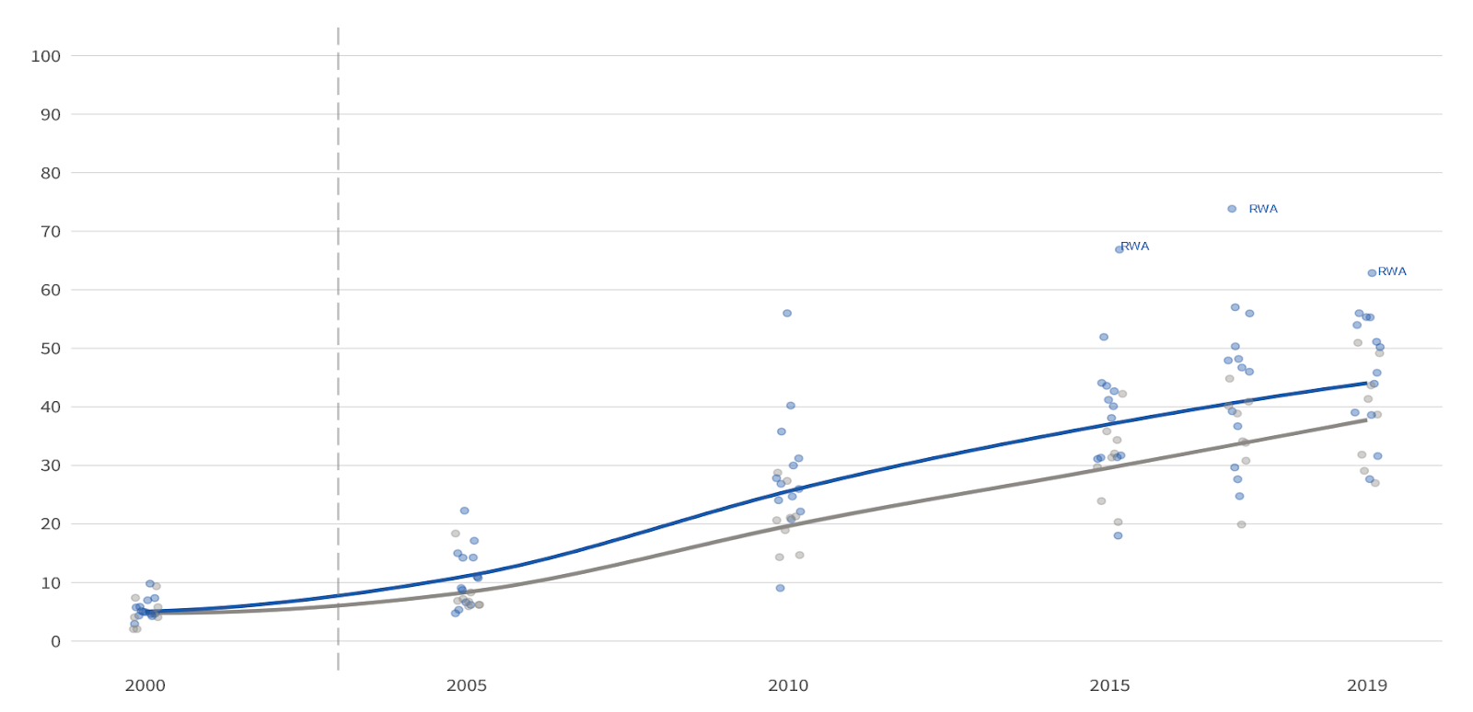

Within the infectious disease sub-index, the population weighted universal health service coverage index was 5 in 2000 and by 2019, this had risen to 44 within countries supported by PEPFAR (Togo, South Sudan, Sierra Leone, Rwanda, Mozambique, Mali, Malawi, Liberia, Ethiopia, Democratic Republic of the Congo, Burundi, Burkina Faso, Uganda) and rose to 38 in countries which are not supported by PEPFAR (Central African Republic, Chad, Gambia, Guinea, Madagascar, Niger, Somalia, Sudan).

**POPULATION WEIGHTED HEALTH SERVICE COVERAGE INDEX (CAPACITY AND ACCESS SUB-INDEX)** IN PEPFAR SUPPORTED LOWER INCOME SUB SAHARAN AFRICAN COUNTRIES REACHES THAT OF NON-PEPFAR SUPPORTED COUNTRIES

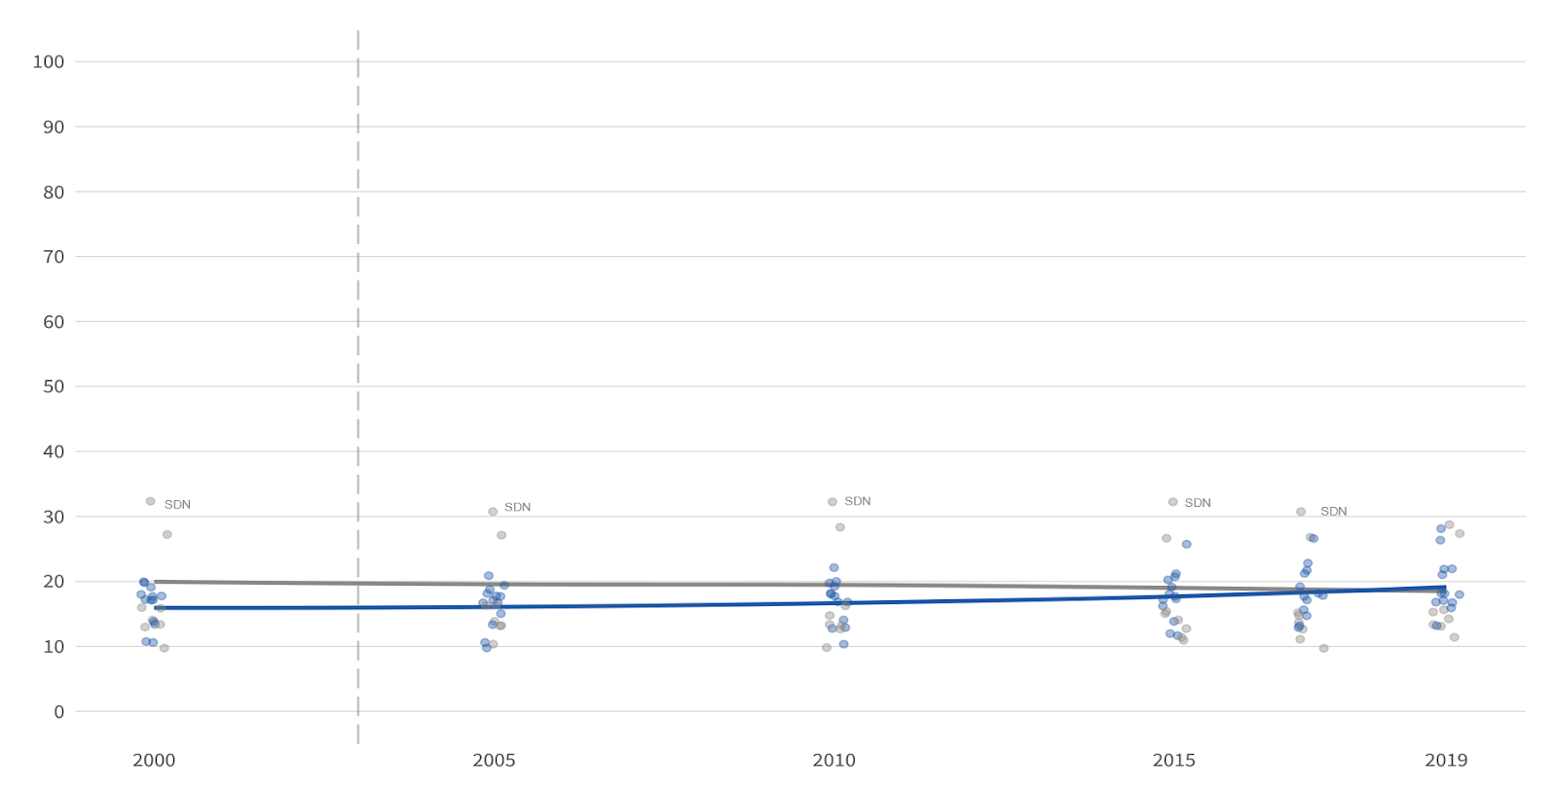

Within the capacity and access sub-index, the population weighted universal health service coverage index was 16 within countries supported by PEPFAR (Togo, South Sudan, Sierra Leone, Rwanda, Mozambique, Mali, Malawi, Liberia, Ethiopia, Democratic Republic of the Congo, Burundi, Burkina Faso, Uganda) in 2000. By 2009, it had risen to 19 to match that of countries which are not supported by PEPFAR (Central African Republic, Chad, Gambia, Guinea, Madagascar, Niger, Somalia, Sudan).

1. World Health Organization Regional Office for Africa. Tracking Universal Health Coverage in the WHO African Region, 2022. *World Health Organization Regional Office for Africa*. Accessed August 17, 2022. https://apps.who.int/iris/bitstream/handle/10665/361229/9789290234760-eng.pdf